Curriculum Overview for RECEPTION – Autumn Term
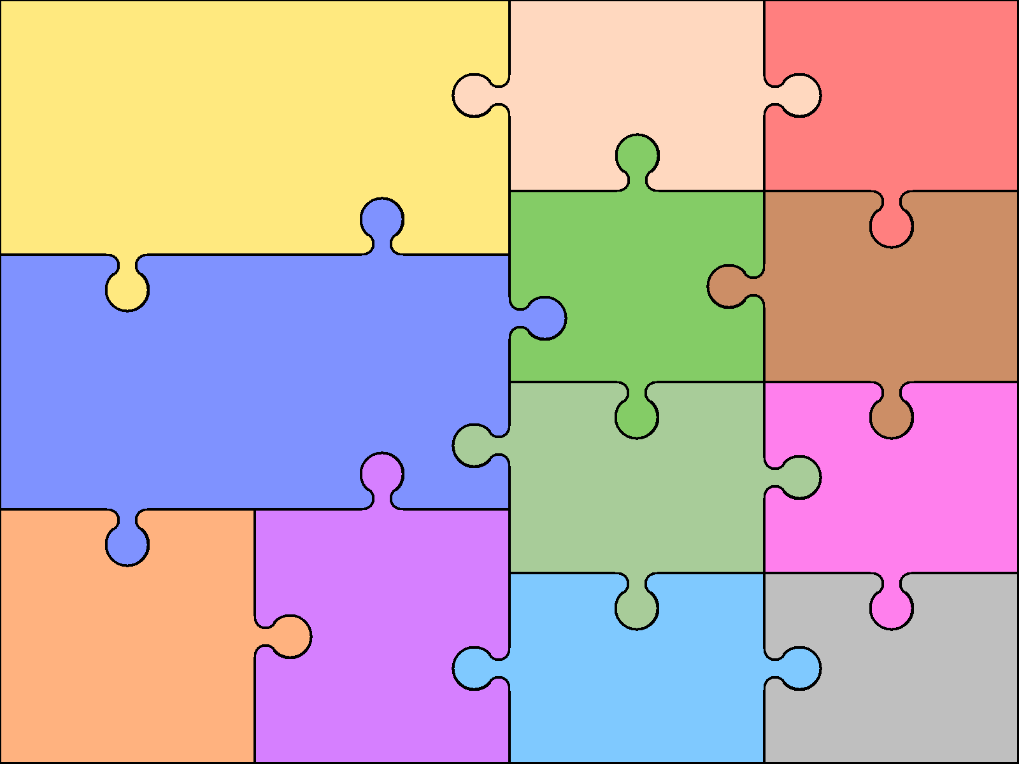  Communication & Language  Listening and attention  • Listens to others one to one or in small groups, when conversation interests them.  • Listens to stories with increasing attention and recall.  • Joins in with repeated refrains and anticipates key events and phrases in rhymes and stories.  • Focusing attention – still listen or do, but can shift own attention.  • Is able to follow directions (if not intently focused on own choice of activity).  • Maintains attention, concentrates and sits quietly during appropriate activity.  • Two-channelled attention – can listen and do for short span. | Speaking  • Beginning to use more complex sentences to link thoughts  • Uses talk to connect ideas, explain what is happening and anticipate what might happen next, recall and relive past experiences..  • Builds up and extends vocabulary that reflects the breadth of their experiences.  • Uses language to imagine and recreate roles and experiences in play situations.  • Links statements and sticks to a main theme or intention.  • Uses talk to organise, sequence and clarify thinking, ideas, feelings and events.  • Introduces a storyline or narrative into their play. |  | Understanding  • Shows understanding of prepositions such as ‘under’, ‘on top’, ‘behind’ by carrying out an action or selecting correct  picture.  • Beginning to understand ‘why’ and ‘how’ questions.  • Responds to instructions involving a two-part sequence.  • Able to follow a story without pictures or props.  • Listens and responds to ideas expressed by others in conversation or discussion and understands humour, e.g. nonsense rhymes, jokes.  . | LITERACY: READING  • Continues a rhyming string.  • Hears and says the initial sound in words.  • Can segment the sounds in simple words and blend them together and knows which letters represent some of them.  • Links sounds to letters, naming and sounding the letters of the alphabet.  • Begins to read words and simple sentences.  • Uses vocabulary and forms of speech that are increasingly influenced by their experiences of books.  • Enjoys an increasing range of books. | LITERACY: WRITING  • Gives meaning to marks they make as they draw, write and paint.  • Begins to break the flow of speech into words.  • Continues a rhyming string.  • Hears and says the initial sound in words.  • Can segment the sounds in simple words and blend them  together.  • Links sounds to letters, naming and sounding the letters of  the alphabet.  • Uses some clearly identifiable letters to communicate  meaning, representing some sounds correctly and in  sequence.  • Writes own name and other things such as labels,captions.  • Attempts to write short sentences in meaningful contexts.
 |  |  |  | MATHEMATICS : NUMBERS  • Recognise some numerals of personal significance.  • Recognises numerals 1 to 5.  • Counts up to three or four objects by saying one number  name for each item.  • Counts actions or objects which cannot be moved.  • Counts objects to 10, and beginning to count beyond 10.  • Counts out up to six objects from a larger group.  • Counts an irregular arrangement of up to ten objects.  • Uses the language of ‘more’ and ‘fewer’ to compare two sets  of objects.  • Finds the total number of items in two groups by counting all  of them.  • Says the number that is one more or one less than a given number.  • Records, using marks that they can interpret and explain. | MATHEMATICS SHAPE, SPACE  • Beginning to use mathematical names for ‘solid’ 3D shapes  and ‘flat’ 2D shapes, and mathematical terms to describe shapes.  • Selects a particular named shape.  • Can describe their relative position such as ‘behind’ or  ‘next to’.  • Orders two or three items by length or height, weight or capacity.  • Uses familiar objects and common shapes to create and  recreate patterns and build models.  • Uses everyday language related to time.  • Beginning to use everyday language related to money.  • Orders and sequences familiar events.  • Measures short periods of time in simple ways.
Personal, Social & Emotional Development  Managing Feeling and Behaviour  • Aware of own feelings, and knows that some actions and words can hurt others’ feelings.  • Begins to accept the needs of others and can take turns and share resources, sometimes with support from others.  • Can usually tolerate delay when needs are not immediately met, and understands wishes may not always be met.  • Can usually adapt behaviour to different events, social  situations and changes in routine. | Self Confidence and Self Awareness  • Is more outgoing towards unfamiliar people and more  •confident in new social situations.  •Confident to talk to other children when playing, and will communicate freely about own home and community.  •Shows confidence in asking adults for help.  •Confident to speak to others about own needs, wants, interests and opinions.  • Can describe self in positive terms and talk about abilities. |  | Making Relationships  • Demonstrates friendly behaviour, initiating conversations and forming good relationships with peers and familiar adults.  • Initiates conversations, attends to and takes account of what others say.  • Explains own knowledge and understanding, and asks appropriate questions of others.  • Takes steps to resolve conflicts with other children, e.g. finding a compromise.
 |  |  |  | Understanding The World  • Remembers and talks about significant events in their own experience.  • Recognises and describes special times or events for family or friends.  • Shows interest in different occupations and ways of life.  • Knows some of the things that make them unique, and can talk about some of the similarities and differences in relation to friends or family..  • Completes a simple task on a computer.  • Can talk about some of the things they have observed such as  plants, animals, natural and found objects.  • Talks about why things happen and how things work.  Tithe Barn Primary School  RECEPTION CURRICULUM  AUTUMN | Expressive Arts and Design  • Begins to build a repertoire of songs and dances.  • Explores the different sounds of instruments.  • Explores what happens when they mix colours.  • Experiments to create different textures.  • Understands that different media can be combined to create new effects.  • Manipulates materials to achieve a planned effect.  • Constructs with a purpose in mind, using a variety of resources.  • Uses simple tools and techniques competently and appropriately.  • Selects appropriate resources and adapts work where necessary.    • Selects tools and techniques needed to shape, assemble and join materials they are using.
Physical Development  Health and Self Care  • Observes the effects of activity on their bodies.  • Understands that equipment and tools have to be used safely.  • Dresses with help.  • Eats a healthy range of foodstuffs and understands need for  variety in food.  • Shows some understanding that good practices with regard  to exercise, eating, sleeping and hygiene can contribute to  good health.  • Shows understanding of the need for safety when tackling  new challenges, and considers and manages some risks.  • Shows understanding of how to transport and store  equipment safely. |  | Physical Development  Moving and Handling  •Uses one-handed tools and equipment, e.g. makes snips in paper with child scissors.  • Jumps off an object and lands appropriately.  • Negotiates space successfully when playing racing and chasing games with other children, adjusting speed or changing direction to avoid obstacles.  • Travels with confidence and skill around, under, over and through balancing and climbing equipment.  • Shows increasing control over an object in pushing, patting, throwing, catching or kicking it.  • Uses simple tools to effect changes to materials.  • Handles tools, objects, construction and malleable materials safely and with increasing control.  • Begins to use anticlockwise movement and retrace vertical lines.  • Uses a pencil and holds it effectively to form recognisable letters, most of which are correctly formed.

