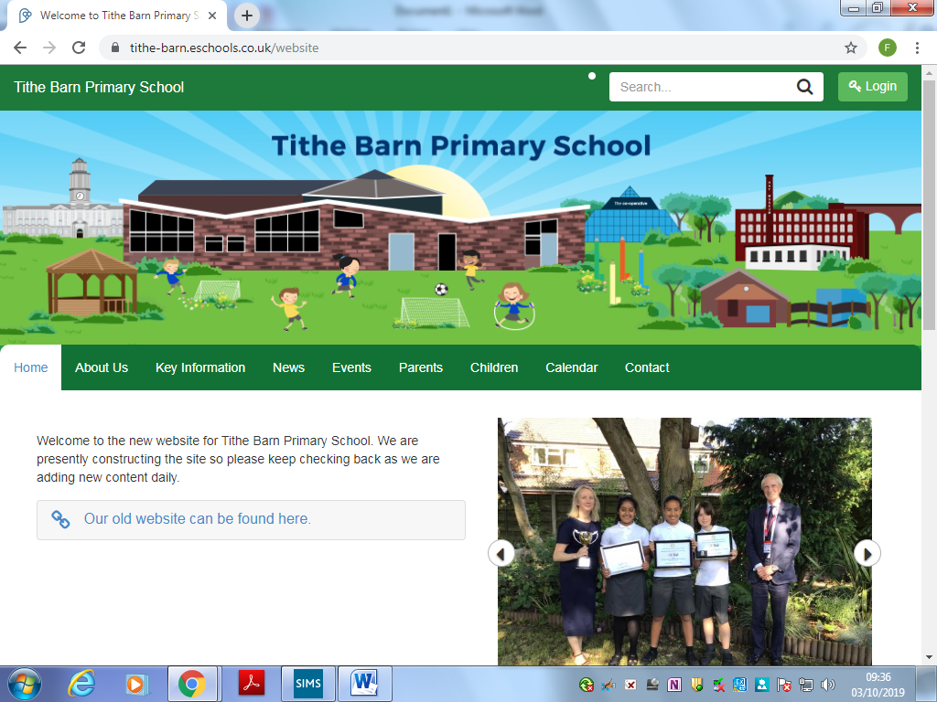

Tithe Barn Primary School

Responding to Low-level Concerns
October 2025

Responding to Low-level Concerns
POLICY AUTHOR | KATHERINE MUNCASTER
RATIFIED BY THE GOVERNING BODY | 5th November 2025
SIGNED: | Trudy McLindon
TO BE REVIEWED: | AUTUMN 2027
REVIEWED AND UPDATES | OCTOBER 2025
UPDATED BY | KATHERINE MUNCASTER (HEADTEACHER)

At Tithe Barn Primary School the following members of the school community hold the following positions
Designated Safeguarding Lead | Deputy Designated Safeguarding Lead | Safeguarding Governor
Katherine Muncaster | Aislinn Ross/Diana Vose  BAASC- Jennie Hughes | Lucy Housley

Concerns or allegations about a member of staff or volunteer should be shared with:
The Headteacher / Principal | Deputy Head / Principal  (in the absence of the Headteacher) | Chair of Governors  (in the event of an allegation against the headteacher)
Katherine Muncaster | Aislinn Ross/Diana Vose | Trudy McLindon

Contents:
Contents

Position Statement
1. Legal framework 0
2. Definitions 0
3. Roles and responsibilities 1
4. Staff behaviour 2
5. Reporting concerns 4
6. Self-reporting 4
7. Evaluating concerns 5
8. Acting on concerns 5
9. Record keeping 7
10. Monitoring and review 8

Appendices
Low-level Concern Reporting Form

Position Statement
Tithe Barn Primary School understands the importance of acknowledging, recording and reporting all safeguarding concerns, regardless of their perceived severity. We understand that, while a concern may be low-level, that concern can escalate over time to become much more serious.
We are committed to providing a safe and secure environment for pupils, and our staff are expected to adhere to high standards of behaviour (code of conduct and Safer working practice are displayed in the staff room). The school has clear professional boundaries, which staff are made aware of and must adhere to. We are committed to ensuring that safeguarding concerns are dealt with quickly, resulting in minimal risk of harm to our pupils and other children.
In line with the expectations set out in Keeping Children Safe in Education 2022 we have developed low level concerns guidance for our school community.
- Legal framework
This policy has due regard to all relevant legislation and statutory guidance including, but not limited to, the following:
- UK General Data Protection Regulation (UK GDPR)
- Data Protection Act 2018
- DfE (2025) ‘Keeping Children Safe in Education 2025’
- DfE (2018) ‘Working Together to Safeguard Children’
This policy operates in conjunction with the following school policies:
- Safeguarding Policy
- Staff Code of Conduct
- Safer working practice guidance
- Whistleblowing/confidential reporting policy
- Data Protection Policy
- Acceptable use policy (Staff)
- Definitions
For the purposes of this policy, a low-level concern is defined as any concern had about an adult’s behaviour towards, or concerning, a child that does not meet the harms threshold (see below), or is otherwise not serious enough to consider a referral at the time of its reporting. Low-level concerns refer to behaviour on the part of a staff member towards child/children, considered inappropriate in line with statutory safeguarding advice, the Staff Code of Conduct, and the Appropriate and inappropriate behaviour subsection of this policy.
Low-level concerns may not be deemed to be harmful or meet the need to refer under the allegations management guidance, but they are significant in keeping children safe. The harms threshold is the point at which a concern is no longer low-level and constitutes a threat of harm to a child. This threshold is defined as accusations that an adult has:
- Behaved in a way that has harmed a child or may have harmed a child.
- Possibly committed a criminal offence against, or related to, a child.
- Behaved towards a child in a way that indicates they may pose a risk of harm to children.
- Behaved in a way that indicates they may not be suitable to work with children, including behaviour that has happened outside of school.
For further detail see- greatermanchesterscb.proceduresonline.com -allegation management
While low-level concerns are, by their nature, less serious than concerns that meet the harms threshold, the school understands that many serious safeguarding concerns, e.g. child sexual abuse, often begin with low-level concerns. The school will ensure that all staff are aware of the importance of recognising and sharing concerns before they escalate from low-level to serious, wherever possible.

- Roles and responsibilities
The governing board is responsible for:
- Ensuring that the school complies with its duties under child protection and safeguarding legislation.
- Ensuring that policies, procedures and training opportunities with regard to reporting safeguarding concerns are compliant and effective.
- Guaranteeing there is an effective Staff Code of Conduct that outlines behavioural expectations.
- Ensuring that a suitably trained Designated Safeguarding Lead has been appointed, alongside a Deputy DSL where appropriate.
- Ensuring that there are robust reporting arrangements, including inter-agency collaboration.
- Ensuring that there are appropriate procedures in place to handle allegations and low-level concerns reported against members of staff.
The headteacher is responsible for:
- Being a point of contact for all staff when they have safeguarding concerns, whether serious or low-level.
- Assessing whether safeguarding concerns about staff members meet the threshold for being termed an allegation, or whether they are low-level concerns.
- Implementing this policy, and all related policies, throughout the school, and ensuring that staff adhere to it at all times.
- Safeguarding pupils’ wellbeing and maintaining public trust in the teaching profession.
- Ensuring that all staff have undertaken safeguarding training.
- Ensuring that all staff have an ongoing awareness of low-level concerns and reporting procedures.
The Deputy DSL is responsible for:
- Being a point of contact for all staff when they have safeguarding concerns, whether serious or low-level.
- Assessing whether safeguarding concerns about staff members meet the threshold for being termed an allegation, or whether they are low-level concerns.
- Following all procedures outlined in this policy for acting upon low-level concerns.
- Liaising with the Headteacher, staff members, the governing board and all relevant agencies to act upon concerns, where necessary.
- Keeping detailed, accurate and secure records of all low-level concerns and any actions taken.
Staff are responsible for:
- Adhering to all the relevant policies and procedures, including acting within the Staff Code of Conduct at all times.
- Interacting with children in a way that is respectful and appropriate for their level of authority and has due regard to the power imbalance between children and staff members.
- Understanding the importance of reporting low-level safeguarding concerns.
- Reporting all safeguarding concerns, they may have about children immediately.
- Reporting all safeguarding concerns, they may have about the behaviour of a member of staff immediately.
- Staff behaviour
Appropriate and inappropriate behaviour
The school will ensure that all staff members are aware of the standards of appropriate behaviour expected towards children.
Staff will ensure that they pay due regard to the fact that:
- They are in a unique position of trust, care, responsibility, authority and influence in relation to children.
- There is a significant power imbalance in the child-staff dynamic.
- There are more stringent expectations on their behaviour with regard to children due to their position as a public professional.
Staff will remain aware of the fact that all pupils under the age of 18, regardless of the phase and year group they are at within the school, are children by law – resultantly, staff will ensure that they do not assume maturity on behalf of a child and do not engage with children as they would with their own peers. Staff will be aware that, where there is any doubt regarding whether the behaviour of another adult is appropriate, it will be reported to a DSL immediately.
Inappropriate behaviour can exist on a wide spectrum, from inadvertent or thoughtless behaviour, to behaviour ultimately intended to enable abuse. Examples of inappropriate behaviour that would constitute a low-level concern in need of reporting to a DSL include:
- Being overly friendly with children – this could include, but is not limited to, communicating with a child through personal social media or allowing inappropriate conversations or enquiries to occur with children, e.g. conversations that are about a staff member’s personal life or could be interpreted as having a sexual nature.
- Having favourites – this could include, but is not limited buying children gifts, treating the child differently to fellow peers.
- Taking photographs of children on their personal mobile phones or devices.
- Engaging with a child on a one-to-one basis in a secluded area or behind a closed door unless part of usual practice (e.g. social worker/child) or deemed appropriate within context and agreed by a Headteacher.
- Using inappropriate, sexualised, intimidating or offensive language.
- A member of staff that has behaved in a way in their personal life that raises safeguarding concerns.
- The member of staff have, as a parent or carer, become subject to child protection procedures;
- The member of staff is closely associated with someone in their personal lives (e.g. partner, member of the family or other household member) who may present a risk of harm to child/ren for whom the adult is responsible in their employment/volunteering.
- The behaviour is not consistent with the standards and values of the school, and which does not meet the school expectations encapsulated in their staff code of conduct.
Staff will be aware that some of the above low-level concerns may meet the harms threshold. This will be dependent on certain factors, e.g. the age or needs of the child or the content of exchanged messages, and that some of the above incidents may not be concerns in context, e.g. a pre-approved, one-to-one meeting with a child behind a closed door between the child and a staff member who has received all appropriate safety checks.
Staff will also be made aware that behaviour which raises concerns may not be intentionally inappropriate, and that this does not negate the need to report the behaviour. Staff members who engage in low-level inappropriate behaviour in relation to pupils inadvertently will be made aware, and supported, to correct this behaviour in line with the Staff Code of Conduct. A Headteacher will also evaluate whether additional training would be beneficial for any staff members exhibiting concerning behaviour, or the staff cohort as a whole where low-level concerning behaviour is seen more widely.
School Culture
The school understands that spotting the early signs of harmful behaviour towards children can be difficult, and that many will be hesitant to report concerns they have about their colleagues’ behaviour, particularly the behaviour of their superiors. Staff are encouraged to maintain an attitude that recognises that abuse can happen anywhere, in any setting, and that anyone can be a perpetrator regardless of their age, sex, level of authority, personality, etc.
The school will ensure that all staff members have received training as part of their induction that outlines appropriate behaviour towards pupils for staff members. All staff will read, understand and adhere to the Appropriate and inappropriate behaviour subsection of this policy, as well as the Staff Code of Conduct.
Staff will address any questions they have regarding safeguarding to a DSL. The school will work to foster an environment where personal and professional boundaries are clearly set and respected for all individuals in the school community, e.g. children are not treated as friends and an appropriate professional distance is maintained by staff.
The school will ensure that all staff are sufficiently trained surrounding the reporting of safeguarding concerns as part of their induction, and that refresher training is conducted as necessary. The school will ensure that all staff understand how to recognise and report safeguarding concerns. Staff will be trained to identify concerning or problematic behaviour towards pupils that may indicate a safeguarding concern, and how to identify signs of abuse or harm in pupils.

Evaluating School Culture Following Concerns
The school will ensure that appropriate consideration is given to the school’s culture and whether or not it has enabled the inappropriate behaviour to occur. The Headteacher will review whether any changes need to be made to relevant policies or training programmes in light of any evaluations of the school’s culture, in order to achieve an open and transparent culture that deals with all concerns promptly and appropriately.
- Reporting concerns
The school will promote a culture in which safeguarding pupils is the uppermost priority, beyond any perceived professional loyalties to colleagues, ensuring that staff are actively encouraged to report concerns, regardless of their relationship with the staff member.
Staff will report all safeguarding concerns they have to a Headteacher immediately in line with the procedures laid out in the Safeguarding Policy. Staff members will report concerns without undue delay. Where the report concerns a specific incident, staff members will report their concerns no later than 24 hours after the incident where possible. Staff members will be aware that concerns are still worth reporting even if they do not seem serious.
Staff members will report their concerns to a DSL verbally, or by submitting a Low-level Concern Reporting Form. When submitting concerns, staff will take care to ensure that they observe the Confidentiality Reporting Policy and in line with school procedures, and protect the identity of all individuals to which the concern pertains as far as possible.
Staff members may request anonymity when reporting a concern, and the school will endeavour to respect this as far as possible. The school will not, however, promise anonymity to staff members who report concerns in case the situation arises where they must be named, e.g. where it is necessary for a fair disciplinary hearing. In line with the Whistleblowing Policy, staff will be protected from potential repercussions caused by reporting a genuine concern.
Where a low-level concern relates to the Headteacher, it should be reported to the chair of governors.
Where a low-level concern relates to a person employed by a supply agency or a contractor to work in the school, staff will also be required to report this to a Headteacher, who will in turn, inform the employer of the subject of the concern.
All concerns reported to a Headteacher will be documented in line with Record Management. Where appropriate a DSL will refer to the Local Authority Designated Officer (LADO) for advice.
- Self-reporting
On occasion, a member of staff may feel as though they have acted in a way that:
- Could be misinterpreted.
- Could appear compromising to others.
- They realise, upon reflection, falls below the standards set out in the Staff Code of Conduct or violates the Inappropriate Relationships with Pupils Policy.
The school will ensure an environment is maintained that encourages staff members to self-report if they feel as though they have acted inappropriately or in a way that could be construed as inappropriate upon reflection. To the best of their ability, the DSL will maintain a culture of approachability for staff members, and will be understanding and sensitive towards those who self-report.
Staff members who self-report will not be treated more favourably during any resulting investigations than staff members who were reported by someone else; however, their self-awareness and intentions will be taken into consideration.
- Evaluating concerns
Where a Headteacher is notified of a safeguarding concern, they will use their professional judgement to determine if the concern is low-level or if it must be immediately escalated, e.g. where a child is at immediate risk of harm. When deciding if a concern is low-level, the DSLs will seek advice from external agencies where there is any doubt about how seriously to take the concern. When seeking external advice, the Headteacher will ensure they adhere to the Data Protection Policy, and the information sharing principles outlined in the Safeguarding Policy, at all times.
To evaluate a concern a DSL will:
- Speak to the individual who raised the concern to determine the facts and obtain any relevant additional information.
- Review the information and determine whether the behaviour displayed by the individual about whom the concern was reported is consistent with the Staff Code of Conduct and the law.
- Determine whether the concern, when considered alongside any other low-level concerns previously made about the same individual, should be reclassified as an allegation and dealt with alongside school procedures.
- Consult with, and seek advice from, external agencies when in doubt over the course of action to follow, contacting LADO as appropriate.
- Speak to the individual about whom the concern has been raised to inform them of the concern and to give them an opportunity to respond to it.
- Ensure that accurate and detailed records are kept of all internal and external conversations regarding evaluating the concern, and any actions or decisions taken.
- Acting on concerns
Where the concern is unfounded
If, upon evaluation, it is discovered that the low-level concern refers to behaviour that was not considered to be in breach of the Staff Code of Conduct, The Headteacher will speak to the individual to discuss their behaviour, why and how the behaviour may have been misconstrued, and what they can do to avoid such misunderstandings in the future. The Headteacher will also speak to the individual who shared the concern, outlining why the behaviour reported is consistent with school standards and the law. The Headteacher will take care to ensure that conversations with individuals, who reported concerns that transpired to be unfounded, do not deter that individual from reporting concerns in the future.
DSLs will discuss the concerns to discern whether the behaviour, and the reporting of this behaviour, is indicative of ambiguity in the school’s policies or procedures, or the training it offers to staff. Where such ambiguity is found, DSLs will work together to resolve this with input from other staff members, as necessary.
Where the concern is low-level
Where a Headteacher determines that a concern is low-level, the school will respond to this in a sensitive and proportionate manner. The following procedure will be followed:
- The DSL, to whom an incident was reported, holds a meeting with the individual about whom the concern was reported, during which they will:
  - Talk to the individual in a non-accusatory and sympathetic manner.
  - Inform them of how their behaviour was perceived by the individual who reported the concern (without naming them, where possible).
  - Clearly state what was inappropriate and problematic in relation to their behaviour.
  - Discuss the reasons for the behaviour with the individual.
  - Inform the individual clearly, what behaviour would need to change.
  - Discuss any support that the individual may require in order to achieve the proper standards of behaviour.
  - Allow the individual the opportunity to respond to the concern in their own words.
- During the meeting, the DSL would ask the individual to re-read the Staff Code of Conduct and/or other school policies as appropriate, depending on the nature of the concern.
- The DSL would consider whether the individual should receive guidance, supervision or any further training.
- Where considered appropriate in the circumstances, the Headteacher will develop an action plan, with input from the individual, that outlines ongoing and transparent monitoring of the individual’s behaviour and any other support measures implemented to ensure the staff member’s behaviour improves.
- Where it is necessary to undergo an investigation into the behaviour, this will be done discreetly, and information will only be disclosed to individuals on a need-to-know basis.
- Where any child or other individual has been made to feel uncomfortable by the individual’s behaviour, they will be offered pastoral support, where appropriate.
The Headteacher will ensure that all details of the low-level concern, including any resultant actions taken, are recorded and securely stored in line with the Records Keeping and the Data Protection Policy. The Headteacher will ensure that these records are kept organised and up-to-date, so it is easy to refer back to them if any other concerns are reported about the same individual.
The specific approach to handling low-level concerns will be adapted on a case-by-case basis. It is unlikely that a low-level concern will result in disciplinary procedures; however, individuals may be given warnings in line with the schools Capability Policy where behaviour does not improve once it is brought to their attention. Where behaviour does not improve over a longer period of time, the concerns will be escalated and dealt with in line with the Safeguarding policy.

Where the concern is serious
The Headteacher may decide upon evaluation that a concern is more serious than the reporter originally thought, e.g. when viewed in conjunction with other evidence or other concerns made about the same individual. Where this decision is made, the concern will be escalated and dealt with as an allegation. The Headteacher will then follow the procedures laid out in the Safeguarding policy.
- Record keeping
The school will retain all records of low-level concerns, including those that were found to be unfounded. The Headteacher will ensure that all records include the most accurate and up-to-date information and will store them in the electronic low-level concerns file accessible to only the Headteacher/identified member of SLT. The Headteacher will ensure that all low-level concerns are stored together, in an organised and consistent manner, to ensure they can be easily reviewed and analysed where necessary.
Records will include:
- A clear and comprehensive summary of the concern.
- Details of how the concern was followed up and resolved.
- A note of any action taken, decisions reached, and the outcome.
- The name of the individual sharing concerns – if the individual wishes to remain anonymous, this will be respected as far as reasonably possible.
SLT will periodically review the recent low-level concerns made to ensure that they are being appropriately dealt with and to check for any concerning behaviour patterns amongst the staff cohort as a whole. SLT will keep records of these reviews.
Where any concerning patterns of behaviour have been identified, the DSLs will meet to decide on a course of action. Where a pattern of behaviour has become so concerning that it meets the harms threshold, it will be referred to the LADO as soon as practicable.
Records of low-level concerns will not be kept in the personnel file of the individuals to whom the concerns pertain, unless there have been multiple low-level concerns made about the same individual. Where a concern is thought to be serious and is processed as an allegation, records of this will be kept in staff personnel files. Where multiple low-level concerns have been made about the same individual, these will be kept together, and in chronological order.
Where an allegation is made about an individual who has previously been subject to such allegations, or where a low-level concern is reclassified as a serious concern after meeting the harms threshold, all records of low-level concerns about that individual will be moved to the staff personnel file and kept alongside records of the allegation.
The headteacher will ensure that all records are kept in a manner that is consistent with the Data Protection Policy. Records will be confidential, kept password-protected, and securely destroyed after the staff member to whom the concerns pertain has left the school.
The school will only refer to concerns about a staff member in employment references where they have amounted to a substantiated safeguarding allegation if:
- it has met the harms threshold and has been found to have basis through investigation
- where it is not exclusively a safeguarding issue and forms part of an issue that would normally be included in a reference, e.g. misconduct or poor performance.
Low-level safeguarding concerns will not be included in a reference, unless they have comprised a pattern of behaviour that has met the harms threshold.

- Monitoring and review
This policy will be reviewed annually by the headteacher and Deputy DSL, and in response to any new safeguarding requirements or concerns surrounding the wider cultural issues in the school.
Low-level Concern Reporting Form
Thank you for reporting your concerns to the safeguarding team; we are grateful to you for taking the safety and welfare of our pupils seriously. Please fill in the below form, including as much detail as you can, and return it directly to a Headteacher or DSL Please refrain from discussing this concern with anyone other than a Headteacher or DSL until the matter has been dealt with. We ask that you keep all details, including the name staff member to whom the concern pertains, confidential.
Your details
Name
Role
Date and time of completing this form
Who is the concern is about
Name
Role
Relationship to the individual reporting the concern, e.g. manager, colleague
Details of concern
Please include as much detail as possible. Think about the following: What behaviour and/or incident are you reporting? What exactly happened? Why does the behaviour and/or incident worry you? Why do you believe the behaviour and/or incident is not consistent with our Staff Code of Conduct?

Details of any children or young people involved
Name(s)
Do you believe there is a risk of harm to the above children or young people, either now or in the future, as a result of the individual’s behaviour? Explain your answer.
Next steps
What would you like to see happen in response to your concern?
Please state any other information that you believe is relevant to the processing of this concern.
Signature
For use by safeguarding team upon receipt of concern
Date and time concern received
Signature of IDENTIFIED MEMBER OF SLT or deputy IDENTIFIED MEMBER OF SLT
Actions to be taken, e.g. no action, investigation, reclassification as allegation meeting the harms threshold/ report/ advice LADO

